Step 1 – Register for access to Partner Portal

- Select this link https://apps.dced.pa.gov/esa-partner/.
- Log in with your Keystone Login username and password. You MUST log in using the user id and password used to submit your grant application.
- Fill out the required fields. (see highlighted fields in the screenshot below). You MUST
use the email address listed for the contact person in your grant application.
- Submit Access Request.

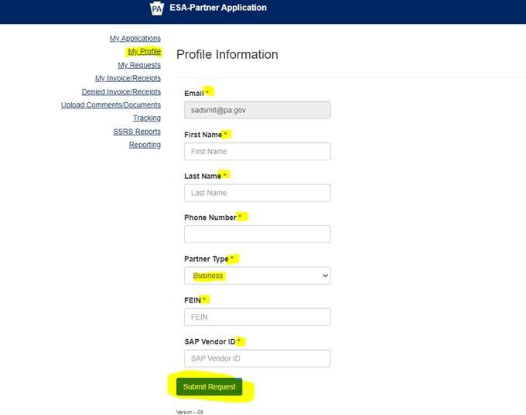

Step 2 – Wait 24 hours for PEMA to approve and assign a Single Application ID# (12-digit number)

Step 3 - Uploading your Final Report form and supporting documents after waiting 24 hours

    - Log into the Partner Portal: https://apps.dced.pa.gov/esa-partner/ . (You will see the screen below)
    - Click on “Upload Comments/Documents”
    - Select Agency as PEMA from the first dropdown
    - Then select the ESA from second dropdown
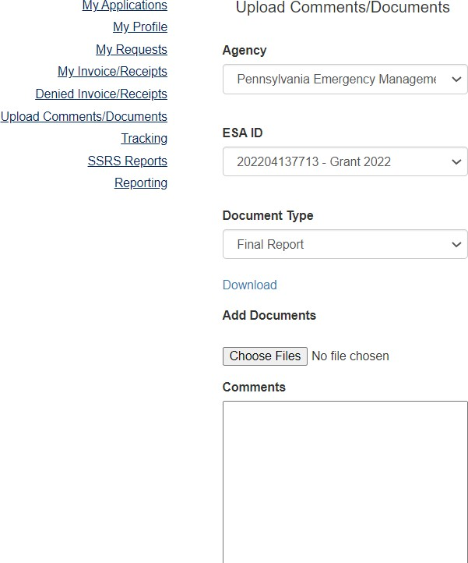
    - Then select “Final Report” as document type from 3rd dropdown to upload the document.

Failure to file a complete Final Report on or before the expiration of the term of the Agreement is grounds for OSFC to seek the return of all Program funds awarded.

